Problem 1 a & b execution screenshot

File name: Sampleins

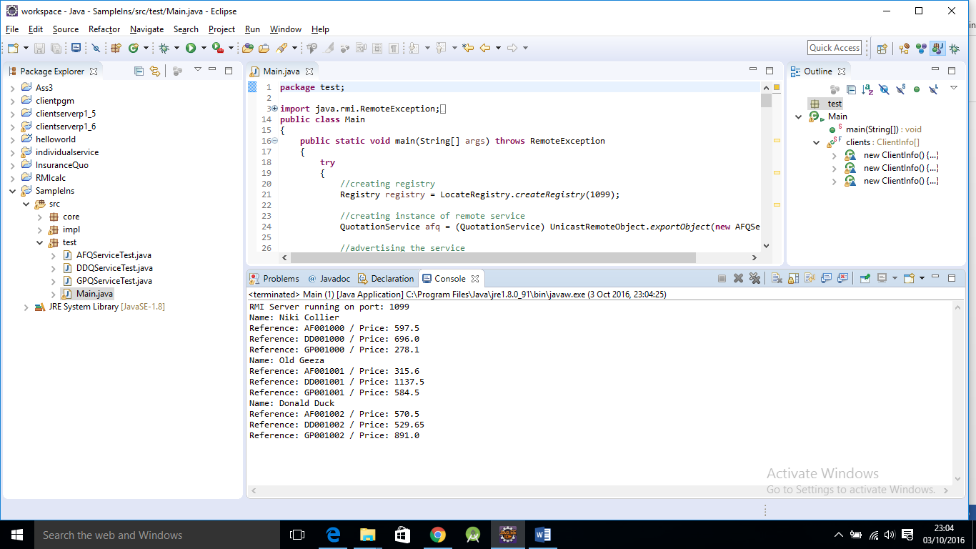

Problem 1 C Execution Screen Shot

File Name: RMI_S_C (AFQService Server, DDQService Server, GPQService Server running parallel)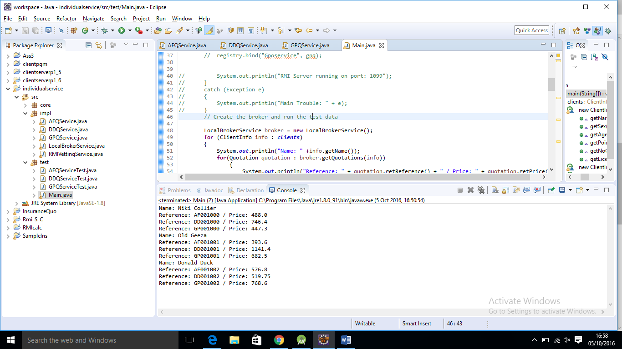

Problem 2 Adding a vetting service

File name: individualservice

Screen shot of problem 2(a)

AFQService

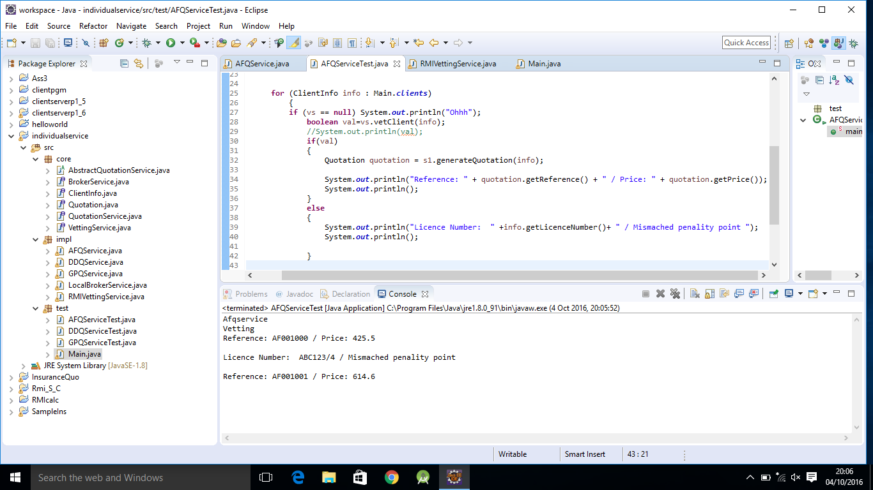

DDQService

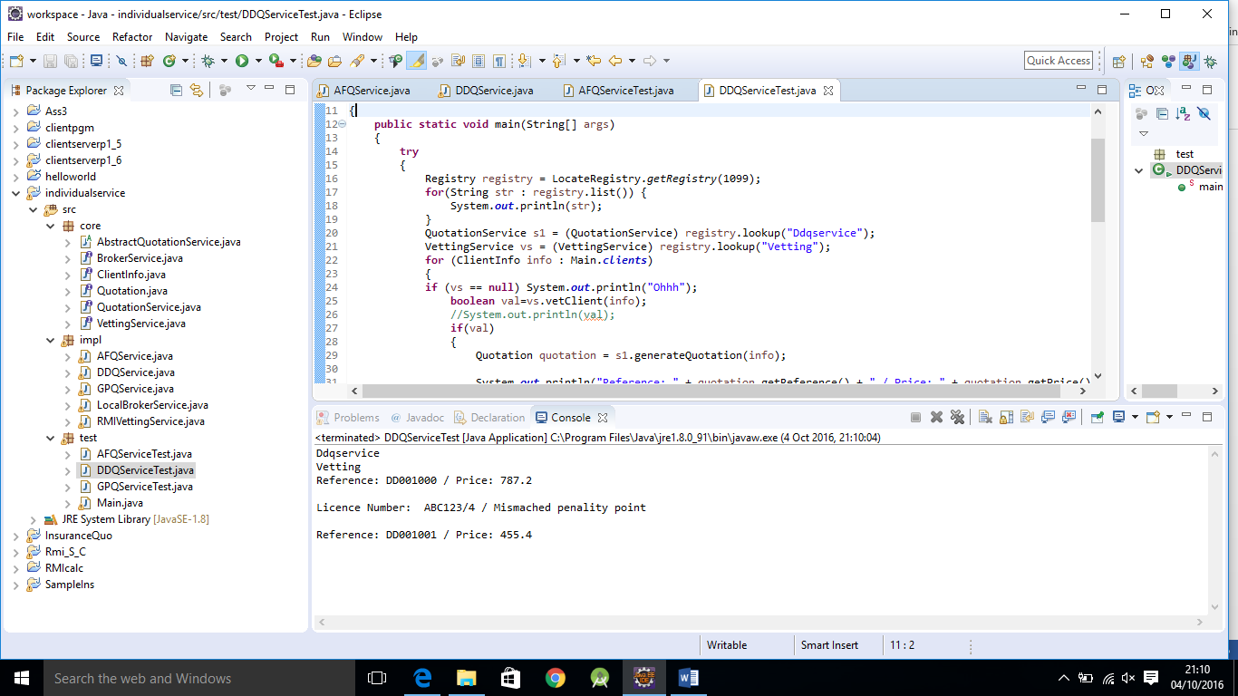

GPQService

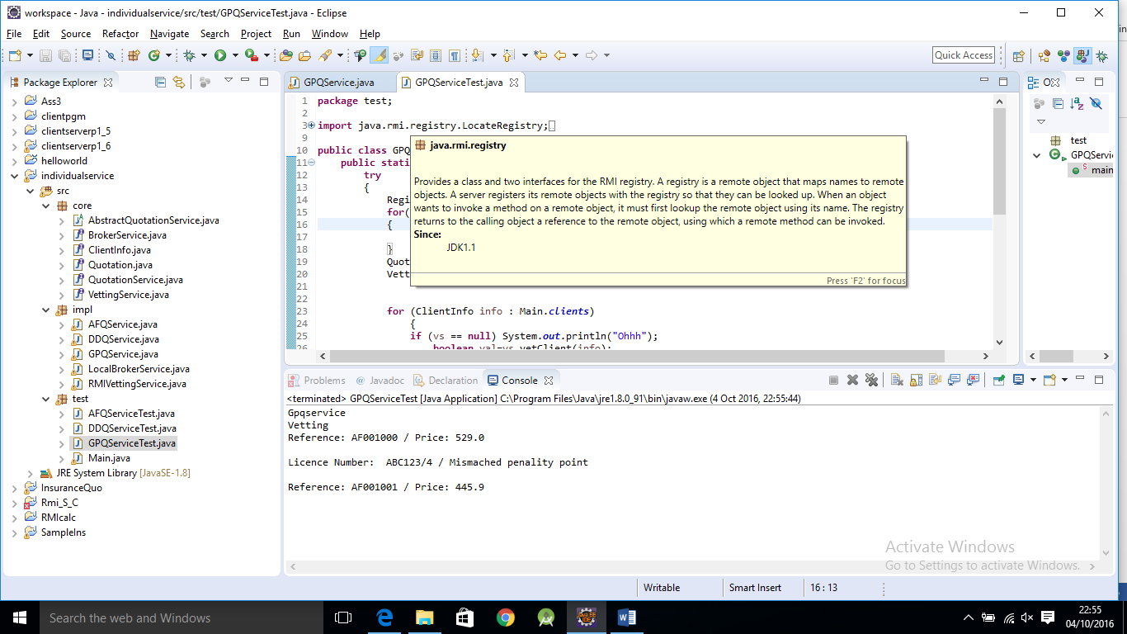

Problem 2(b) screen shot of output

File name: InsuranceQuo

